Discovering Enzyme Regulation with 3D models
What you need to know for the test!
In this lesson you will learn to:
- Compare the location of an allosteric binding site relative to the active site
- Compare the location of a competitive binding site relative to the active site
- Determine how the structure of the active site is changed by binding an allosteric effector
- Describe how structural changes at the active site affect substrate binding affinity
- Determine that product inhibition includes competition
- Determine that product inhibition can include allostery

Models in this activity
You should have received one of the following model sets. Both are identical with the colors reversed.
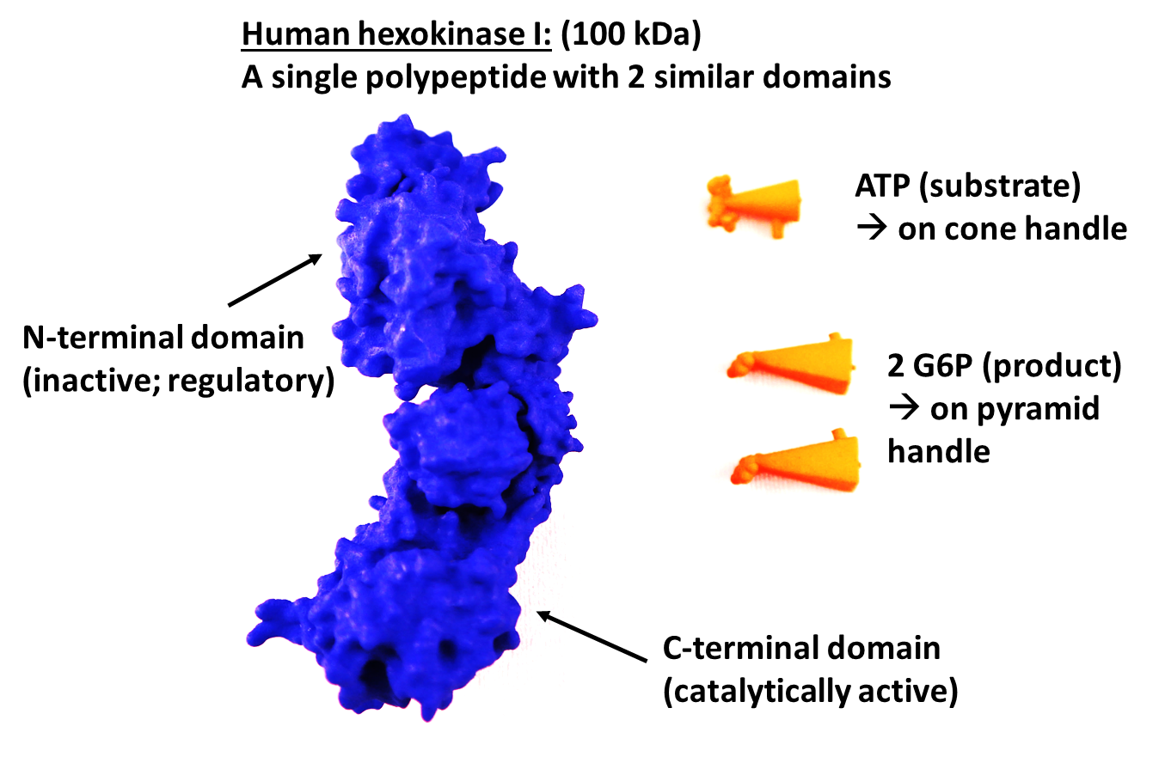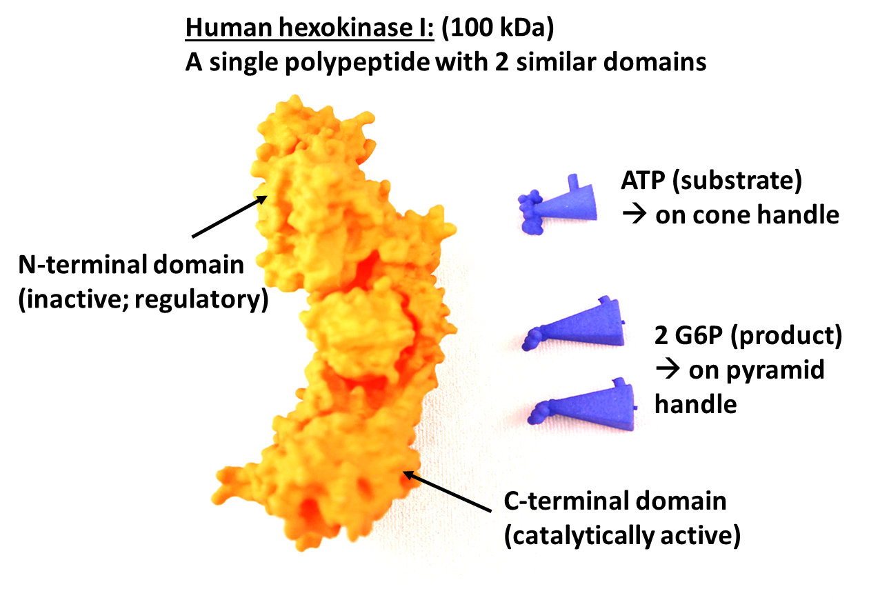
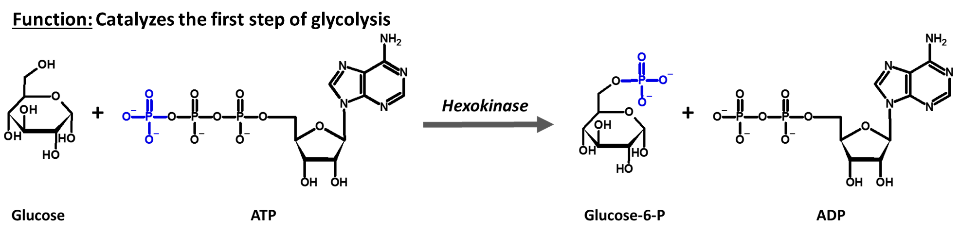

Activity:
- Begin by orienting yourselves with the model set:
  - As you turn the hexokinase (HK) model around in your hand, hold the hexokinase vertically (oriented as shown in the picture). Identify each of the features highlighted in the figure below. Point them out to your group.

  - Do the same for the ATP and G6P models. Compare these models to the chemical structure displayed, where the stick molecules are colored as follows: C-grey, O-red, N-blue, and P-orange.
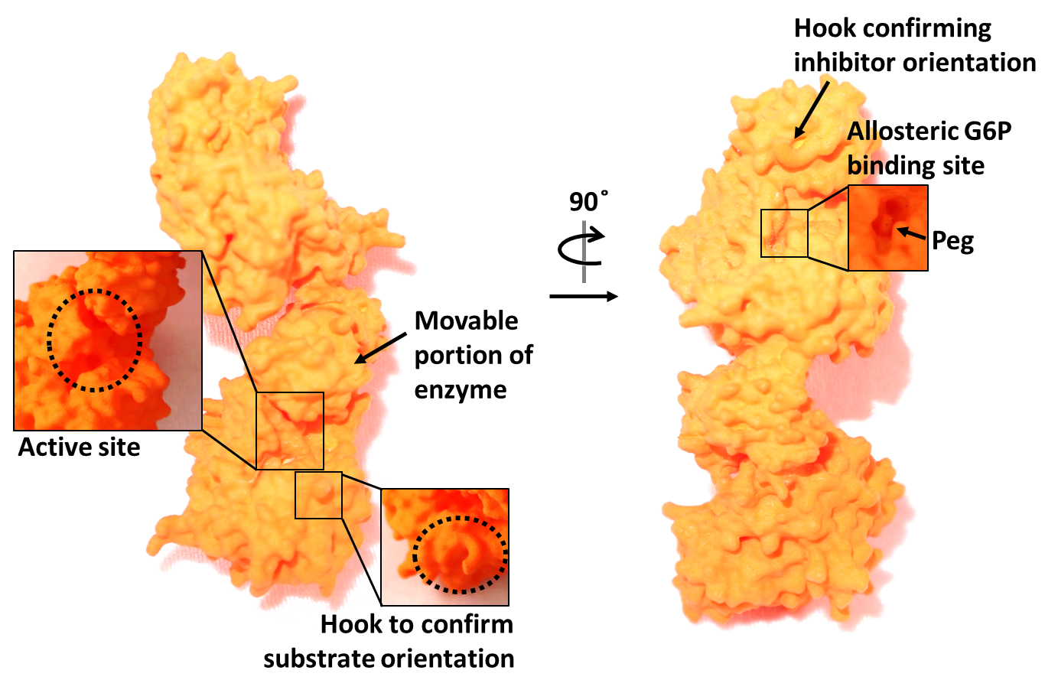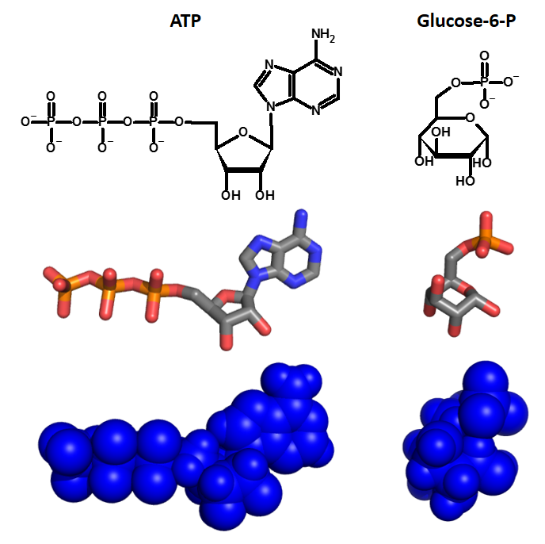

- In the next few steps, we will first look at uninhibited substrate binding to hexokinase; then will look at the effect of two types of product inhibition.
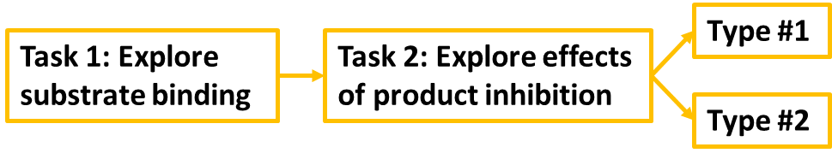

- Insert the ATP (on cone) into the active site:
  - (Ensure that the post on ATP’s cone locks into the hook on the protein)
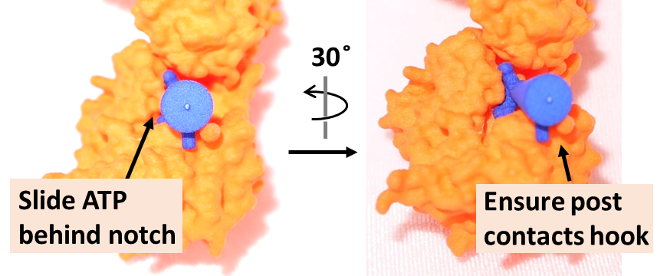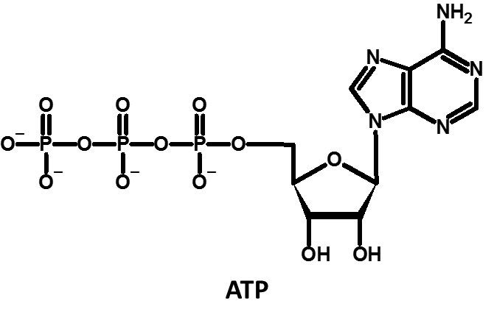

  - Notice the amount of contact between the ATP substrate and HK protein at the binding site.

  - Considering the structure of ATP, predict what types of amino acids and intermolecular forces you expect to bind ATP in the active site?

  - Looking at the figure of the active site, were your predictions correct?
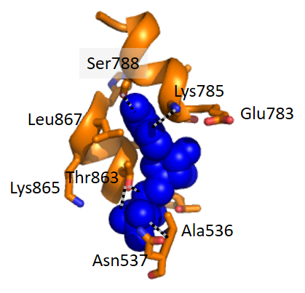
- Now take the glucose-6-P (on rectangular pyramid) and push it into the N-terminal binding site so that the post on the pyramid faces the protein and inserts into the hook on the protein. Correct binding will depress the peg and cause a conformational change in the protein.
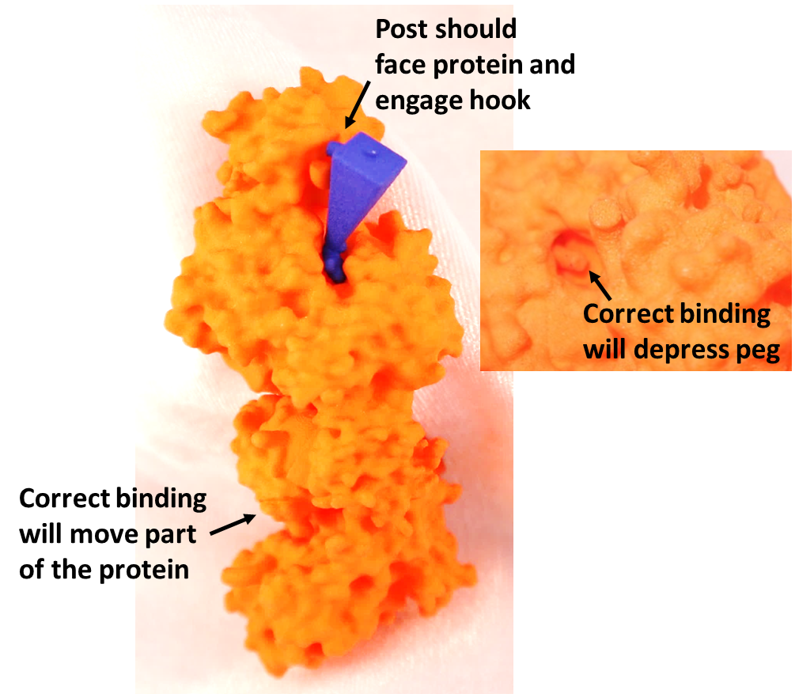
**Pass the model around and have each group member do this**

  - Notice the effect of G6P binding. (Hint: if you are struggling to establish contact between the G6P and peg, you may also use a pencil tip to push the peg down).
Where does the visible change occur in the protein?
    - Near the G6P binding site
    - Distant from its binding site of G6P

  - (Move the G6P in and out of the binding site to compare the effect of its binding on the active site)
With the G6P bound, the active site has:
    - More space
    - Less space

  - Is ATP bound as tightly as it was before?

  - Looking at the figure of the active site, how does G6P binding affect the ATP-hexokinase interactions? (Record your answers below)
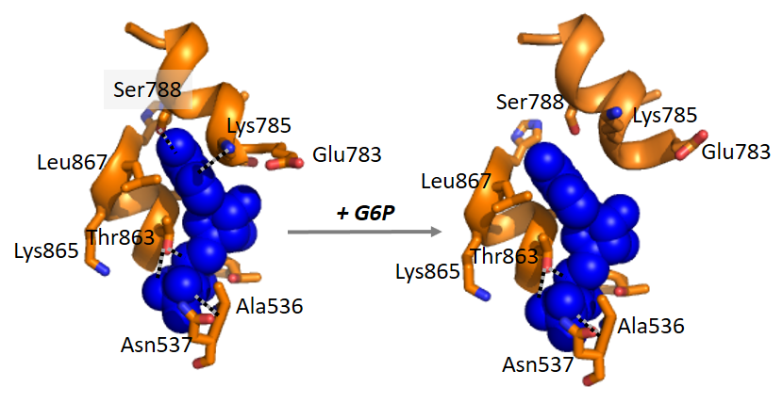

  - Which has more affinity for ATP?
    - Hexokinase
    - Hexokinase + G6P

  - Is G6P an activator or inhibitor? Discuss your reasoning with your group.
    - Activator
    - Inhibitor

  - How will G6P binding affect the conversion rate of Glucose and ATP to G6P? Discuss your reasoning with your group.

  - What kind of inhibition is this? Select all that apply.
    - Product inhibition
    - Allosteric inhibition
    - Competitive inhibition
    - Back reaction (Products Substrates)

  - How does G6P’s allosteric inhibition influence hexokinase’s efficiency at converting glucose to glucose-6-P?
    - Decreases efficiency
    - Increases efficiency
    - Prevents reaction entirely

  - Explain your answer to your group by reflecting on the binding affinity to the substrate.

- Remove the ATP and replace it with G6P as shown below.
  - With G6P in the active site, try to insert ATP in the active site. Does it fit?

  - G6P is acting as an inhibitor in this way, too. What kind of inhibition is this? Select all that apply.
    - Product inhibition
    - Allosteric inhibition
    - Competitive inhibition
    - Back reaction (Products Substrates)

  - While G6P is bound to the active site, can hexokinase convert glucose to G6P?
    - Yes
    - No
  - Would this be true of every competitive inhibitor?
    - Yes
    - No

- Consider the inhibition of hexokinase by G6P.
  - Describe the type of interactions between the G6P and hexokinase?
    - Non-covalent
    - Covalent

  - Is G6P inhibition of hexokinase reversible or irreversible?
    - Reversible
    - Irreversible

- Now have both G6P molecules “bound” to hexokinase at the same time (one at the allosteric site and one at the active site).
  - Is this possible?

  - What are all the factors that determine where G6P binds?

