Discovering Protein Structure with 3D models
What you need to know for the test!
In this lesson you will learn:
- Molecular representations you will be responsible for interpreting on tests.
- How amino acids of a protein interact to make “secondary structures”
- How amino acids of a protein interact to make “tertiary structures”
- How proteins interact with solvent
- Why protein flexibility is important
- How protein regions can be made more stable or more flexible

Models in this activity
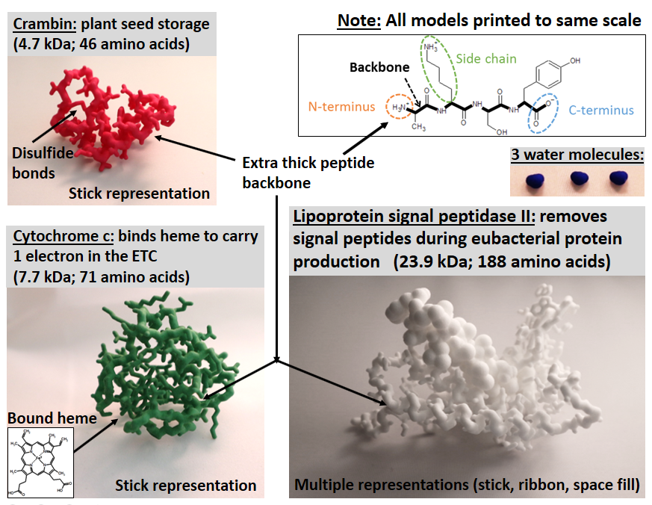
In-class activity:
- Introduction to secondary structures
Amino acids are the smallest repeated unit in a protein. These form additional repeating substructures in a protein’s backbone. There are 3 types of substructures that we call “secondary structures” that occur in crambin, cytochrome c, and lipoprotein signal peptidase.

Analogy: As a block is a unit of a wall, and a wall is a unit of a house, so an amino acid is a unit of a secondary structure, and a secondary structure is a unit of a protein.

Distribute the models within the group so that each member of the group gets one. During the next few activities, you will become experts on your protein.
- Try to identify secondary structures: start at one end of the protein model and trace the thick backbone with your finger until you reach the other end. As you trace the backbone, identify any structure that seems regular. These can include many or few amino acids, but will follow the same structural trends.
Compare your models and findings within your group to identify these regularly repeated units.

***Stop for class discussion***

- Scientists depict proteins in different ways for different purposes (e.g., stick, space fill, and ribbon). In this question, you will also use the lipoprotein signal peptidase II (white model) which has been 3D printed with different regions of the protein displayed in different representations for comparison:
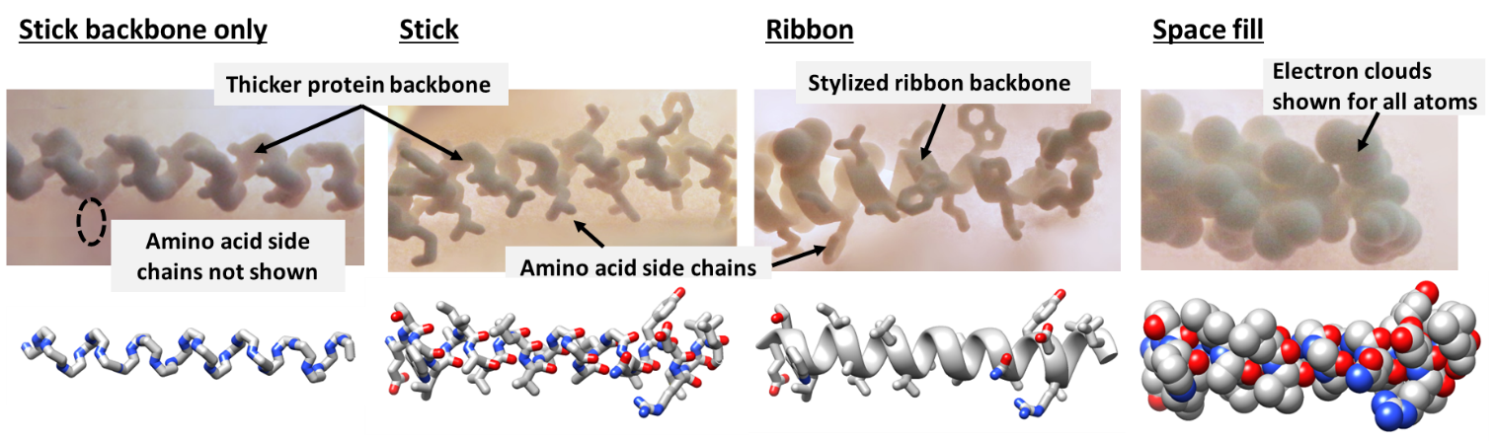
- Compare the different representations as you answer the following questions:
  - Which representation(s) make it clearest where the backbone actually is?
  - Which representation(s) make it clearest where the surface of the protein is?
  - Which representation(s) make it clearest what the amino acid side chains are?

- Test your understanding of α-helices and β-sheets. The following figure illustrates secondary structures represented in your models. How many of each structure are in your model?
(Hint: start at one end of the protein and trace the protein backbone from one end to the other as you identify the structures)
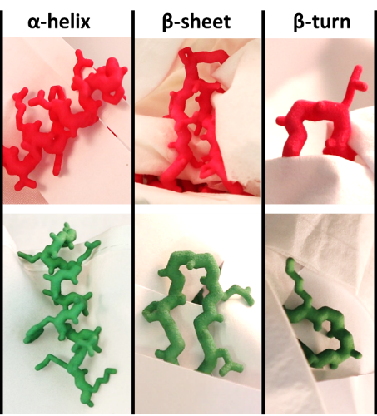
  - Crambin protein (pink)
    - α-helices: ______
    - β-sheets: ______
      - Total number of β-strands in sheets: _____

  - Cytochrome c protein (green)
    - α-helices: ______
    - β-sheets: ______
      - Total number of β-strands in sheets: _____

  - Lipoprotein signal peptidase II (white)
    - α-helices: ______
    - β-sheets: ______
      - Total number of β-strands in sheets: _____

- For α-helices:
  - Compare the amino acids between 2 or more α-helices (in your model or compared to another).
    - Are the side chains the same or different between α-helices? ____ __
    - Is the arrangement of the peptide backbone the same or different between α-helices? ____ __
  - Based on your responses above, which parts of the amino acids provide repeated bonds in an α-helix? (side chains or peptide backbones)? ____ _

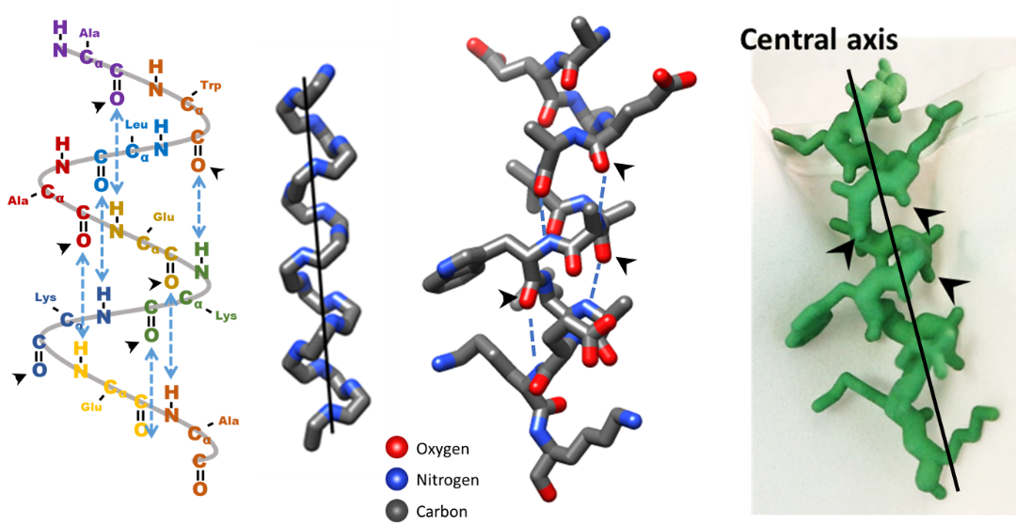
  - Looking at these figures of an α-helix, what intramolecular forces stabilize the secondary structure?

    - T/F Covalent bonds
    - T/F Hydrogen bonds
    - T/F Ionic bonds (electrostatic interactions)
    - T/F Disulfide bonds

- Do you predict that there is enough space within an α-helix for a water molecule to fit?

- Take a blue space filling water molecule and try to fit it into the interior of an α-helix. Does it fit?
  - For the lipoprotein signal peptidase II model, try the water in each representation and show your group what happens.
  - When you consider the actual space that the atoms in a helix take up, could water travel through the inside of an α-helix? _____

***Stop for clicker question and class discussion***

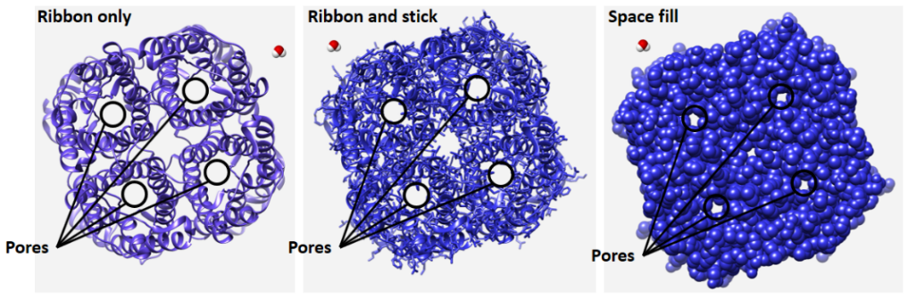(human aquaporin, PDB: 3D9S).

- Stabilizing tertiary structure
The following steps will help you determine the forces that contribute to the stability of protein tertiary structure.
- Pick up your model and find two α-helices next to each other.
  - On both helices, what part of the amino acids are closest together?
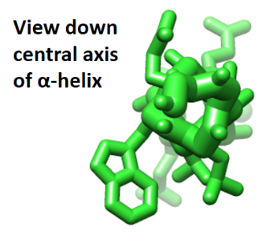
    - Backbone
    - Side chain

  - Where are the side chains located compared to the spiral backbone of the α-helix?
    - Inside
    - Outside

  - Based on your experiences with these two steps, what part of the amino acid provides stability to the tertiary structure?
    - Peptide backbone
    - Amino acid side chains

- Different regions of proteins need to be flexible for different reasons. Pass the models around to compare the flexibility of each protein. Wiggle the models gently.
  - Which protein is the least flexible?
    - Lipoprotein signal peptidase II (white model)
    - Cytochrome c (green model)
    - Crambin (pink model)

  - What is allowing flexibility? (short answer)

- Visualizing protein electron clouds
- In the lipoprotein signal peptidase II model, compare the apparent space between the following helices:
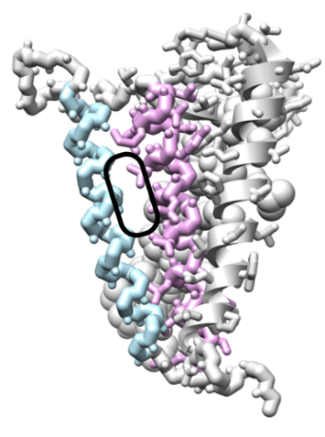
  - Find the blue and purple helices.

    - Can water pass through the space circled above?
    - What if the protein was in space fill?

  - Find the green and pink helices. In this picture, the electron clouds for many atoms are shown as spheres.
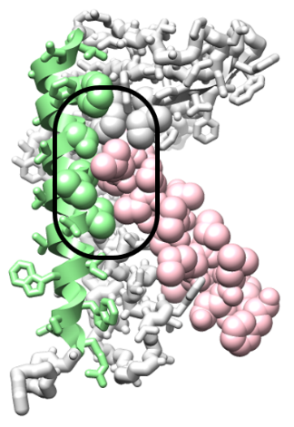

    - Is there more or less space in the circled region compared to the first two helices?

Extra bonus questions/if time allows (Secondary and tertiary structure)!
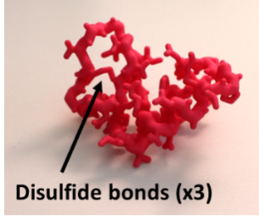
- Crambin’s family of proteins, the thionins, attack cells invading plants. They are very stable to stay folded in hostile environments. Three disulfide bonds contribute to the protein’s structure. Locate the disulfide bonds now. What amino acid forms disulfide bonds? _______
- Can all amino acids adopt specific secondary structures equally well? ___ _
- On the crambin and lipoprotein models, find the prolines located at the ends of the alpha helices. Considering the structure of proline, briefly explain why this amino acid is located at the ends of the alpha helices and not within the helices?

- (tertiary structure) Relate function and structure: How is flexibility important in the function of proteins? Use the binding of heme observed in cytochrome c as an example in your answer.

- Images A-C are different representations of the same peptide. Answer the following statements to describe the space this part of the protein takes up:
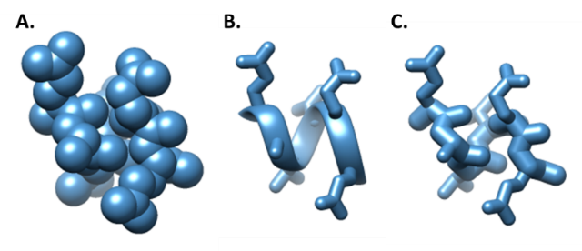
- T or F The electron cloud of A takes up more space than the electron cloud of B or C
- T or F The electron cloud of A, B, and C take up the same amount of space.
- T or F The electron cloud of peptide YYYY takes up more space than the electron cloud of AAAA.

*** Stop here for a clicker question***

- Predicting amino acid location based on function
- Lipoprotein signal peptidase II is a transmembrane protein.
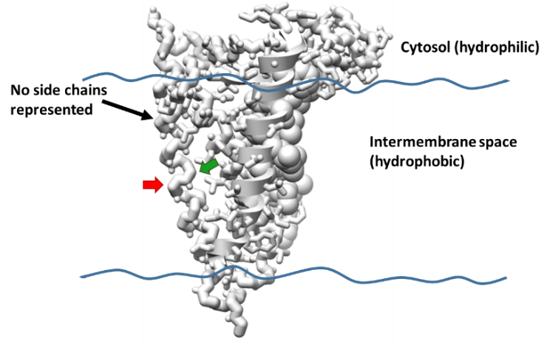
If needed:
Refer to the amino acid cheat sheet at the end of this packet!
  - Find the α-helix marked without side chains represented (black arrow). Then select the residues from the list below that are more likely to be part of the outer face of this helix (red arrow).
    - T or F Serine (Hydrophilic)
    - T or F Isoleucine (Hydrophobic)
    - T or F Phenylalanine (Aromatic)
    - T or F Lysine (Charged)
    - T or F Proline (Hydrophobic)

  - Select the residues below that you would predict to find on this helix facing the inside of the protein (green arrow).
    - T or F Threonine
    - T or F Proline

- Cytochrome c is a soluble protein (green model).
  - Look at the amino acid residues on the surface of the protein and predict or try to identify them. Select the residues from the list below that are more likely to be part of the outer surface.
    - T or F Lysine
    - T or F Glutamine

  - Now consider the amino acid residues inside the protein. Try to identify or predict the amino acids you would expect to find in the core of this protein.
    - T or F Lysine
    - T or F Isoleucine

- Crambin is a plant seed protein that is not soluble in water (pink model).
  - Look at the amino acid residues on the surface of the protein and predict or try to identify them. Select the residues from the list below that are more likely to be part of the outer surface.
    - T or F Isoleucine
    - T or F Leucine

  - Now consider the amino acid residues inside the protein. Try to identify or predict the amino acids you would expect to find in the core of this protein.
    - T or F Cysteine
    - T or F Valine

- Compare the proteins within your group and discuss your reasoning.
  - When are hydrophobic residues on the “outside” of a protein?
  - When are hydrophobic residues on the “inside” of a protein?

(Bonus/with the instructor)
- On your respective model, use the figure below to find the proline residues.
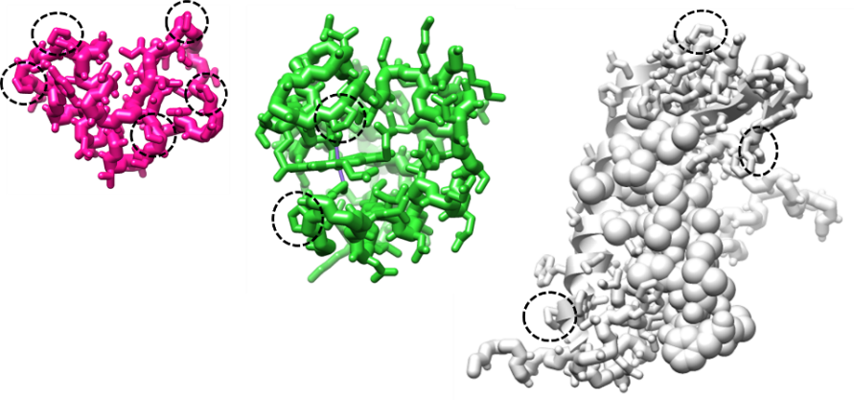
  - Are the proline residues located in or out of secondary structures?
    - If found in secondary structures, do they disrupt the secondary structures?

  - Compare your results with your group. Where are proline residues most often found in relation to the α-helices and β-sheets?
    - T or F In the middle of α-helices and β-sheets
    - T or F At the ends of α-helices and β-sheets
    - T or F Out of α-helices and β-sheets

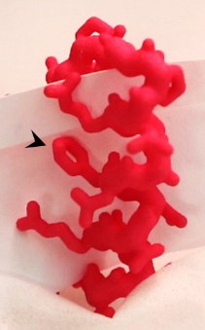
  - Predict what would happen to the longest α-helix if a proline were inserted into the middle of the helix, replacing the phenylalanine.
