Discovering Protein Primary Structure with 3D models
What you need to know for the test!
By the end of this lesson, you should be able to:
- Recognize a variety of molecular representations (i.e. stick and space fill).
- Identify how much space an amino acid takes up if represented in different ways.
- Identify features of the peptide backbone including the amino and carboxyl ends, peptide bonds, and C_{α}.
- Understand the constraints on bond angle in a peptide.
- Estimate electron cloud space.

Models in this activity
This activity includes the following models. For some groups the colors will be reversed from this image:
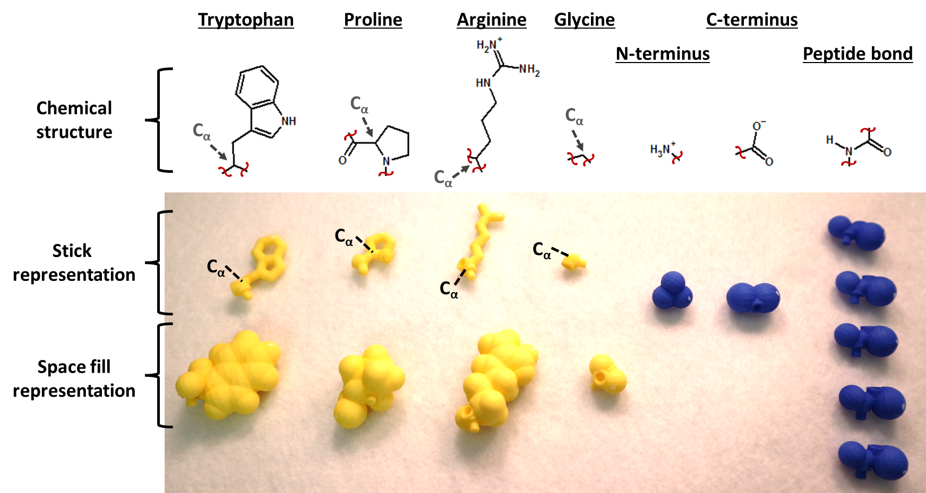
These pieces are interchangeable as they pop together to form different short peptides. They are designed to rotate around the C_{α} bonds while being fixed on the peptide bond.

In class activity:
Begin by giving one amino acid pair to each member of your group. If your group has fewer than 4 members, do not use the Glycine residues at this time.
- Stick vs space fill representations
Protein structures are generally represented by a stick representation so that the main bonds can be seen. Another way of showing a structure is by using the space filling representation, in which all the atoms in a molecule are depicted as spheres whose radii are proportional to the radii of the atoms’ electron clouds. The space fill representation gives a more accurate perspective of the overall electron density of a molecule.

- Using the stick representation of your amino acid, find a stick representation of a C-C bond. Because all peptides contain a C-C bond, you will use the length of this bond as a reference measurement for comparing and predicting the electron clouds of atoms.
  - Overlay this C-C bond over a space fill carbon atom. How many C-C lengths equal the diameter of a carbon atom? _~2__
  - Next, overlay the C-C bond over a space fill hydrogen atom. How many C-C lengths equal the diameter of a hydrogen atom? _~1.2__
  - Finally, overlay the C-C bond over a space fill oxygen atom. How many C-C lengths equal the diameter of an oxygen atom? _~1.5__
  - Compare your findings within your group.

- Using your amino acid pair, overlay the stick model on top of the space fill model so that the stick bonds lay on top of their corresponding space fill atoms.
  - Even though all parts are printed to the same scale, notice how much larger the space fill model is than the stick model (that only shows the bonds).
  - The space fill model shows atoms that are not depicted in the stick model. Based on the chemical structures of the amino acids, what atoms are not shown?
    - Water molecules
    - Hydrogen atoms
    - Oxygen atoms
    - Impossible to tell when displayed in a single color
  - Using the C-C bonds as a reference, select the dotted line that most accurately represents the electron density of each amino acid.
Phe:
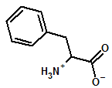
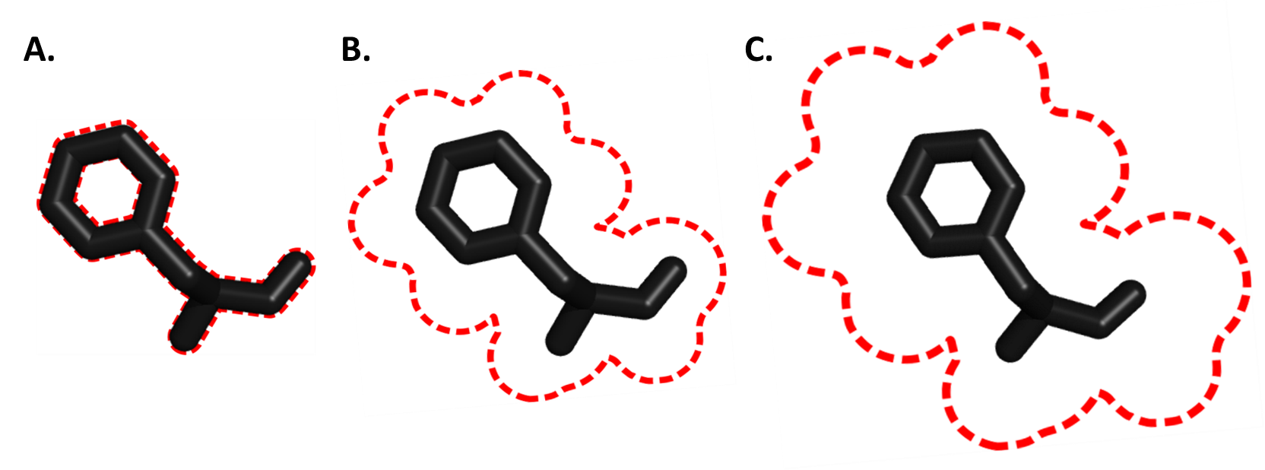 (B)
Asn:
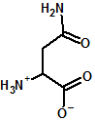
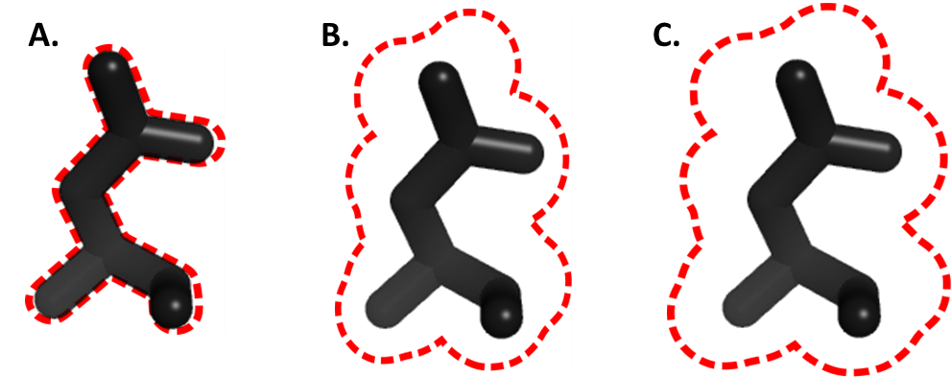 (C)

Ile:
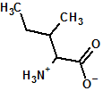
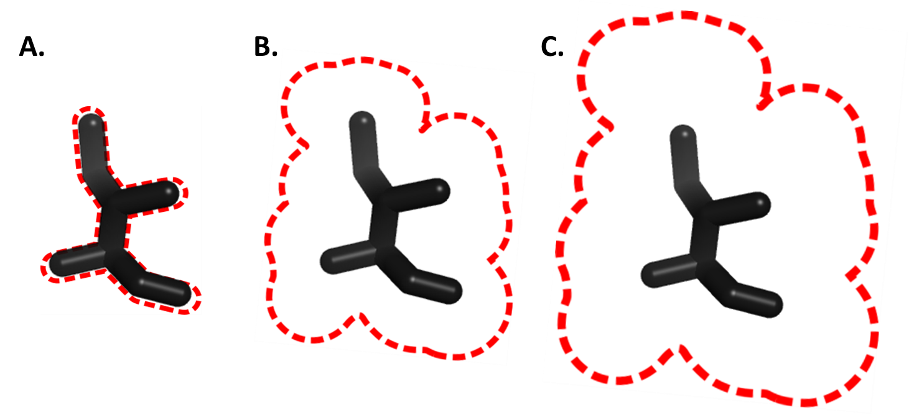(B)

  - Consider the stick and space fill models of the tryptophan residue. Briefly describe how much empty space is within the aromatic ring.
  - Is this enough space for a proton (H+) to pass through the ring? (Pick up your space fill model again as a reference for the size of a proton. Find one of the hydrogens displayed, and consider the size of it. Look at its size in relation to the 6-carbon aromatic ring of the tryptophan. Will it fit through the ring?) _No_
Even in the stick representation (which, isn’t showing the actual size of the molecule), there isn’t enough space for a space fill H to fit!

Take home points:
        - amino acids are crowded
        - amino acids take up lots of space
        - there is no empty space in an amino acid

- Rebecca may discuss resolution/crystallography/trust in lecture here – or later
  - 3x5 card with outlines of electron density at different resolutions
  - Looking at the peptide bond, why didn’t we make it rotate?

- Identifying features of a dipeptide
- Divide the following dipeptides among your group so that each student builds one. Build the dipeptides using the stick models only. Be sure to include a peptide bond between each pair (remember proline already includes the peptide bond)! You will have to take turns building the model, and share the termini:
  - 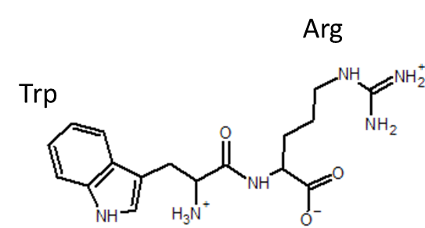
  - 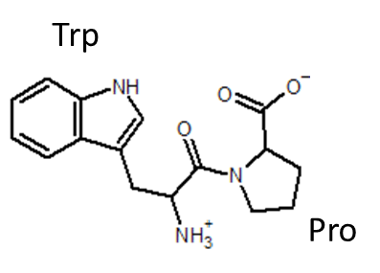
  - 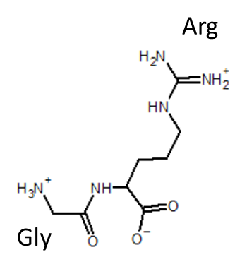

  - Compare the 2D images on the screen to the model in your hand. List the features that are different between the model and the chemical structure:
    - Describe the peptide bond.
    - Compare how flat the model is compared to the 2D image
    - Identify each termini of the peptide. Discuss with your group how you know which termini is which.
    - Which bonds are static and which rotate?

- Now, predict if the amino acids can rotate 180° around their psi (ψ) and phi (φ) bonds. The psi bond is the bond between the C_{α} and the C, while the phi bond is the bond between the C_{α} and the N in the peptide backbone.
  - 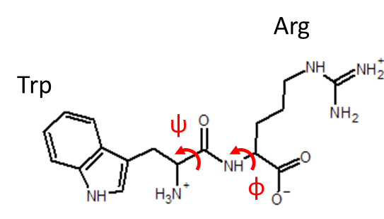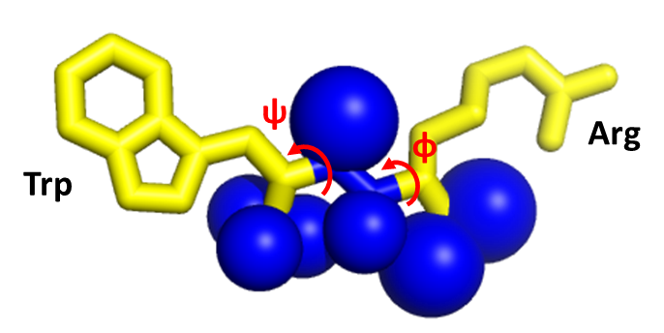
  - 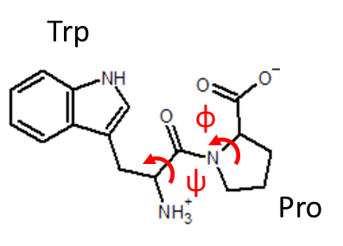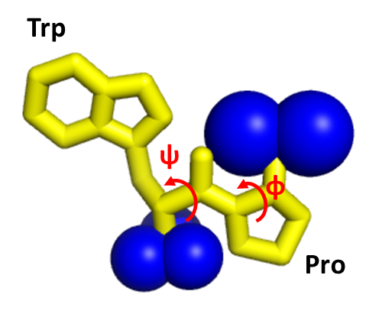
  - 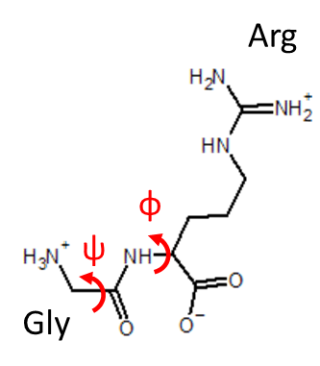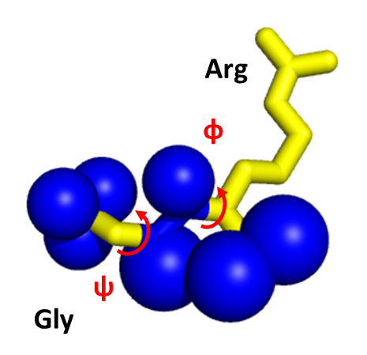
      - For Gly-Arg, predict if a 180° rotation is possible with the N-terminus
      - Then predict if a 180° rotation is possible without the N-terminus

- Now, build the short peptides using the space fill amino acid residues. Then test the rotations around the phi and psi bonds. Determine if the pairs of residues are able to rotate 180° around the indicated phi and psi bonds:
T or F Tryptophan and arginine can rotate 180° around the phi and psi bonds indicated without clashing.
T or F Arginine and proline can rotate 180° around the phi and psi bonds indicated without clashing.
T or F Glycine and arginine can rotate 180° around the phi and psi bonds indicated without clashing – when the N- and C-termini are present.
T or F Glycine and arginine can rotate 180° around the phi and psi bonds indicated without clashing – when peptide bonds are used instead of the N- and C-termini.

- Rank the following amino acid pairs according to their freedom to rotate around the indicated bonds, where 1 = most free and 3 = most hindered.
  - __2__
  - __3__
  - __1__

- Bonus question: Exploring Ramachandran plots
  - Ramachandran plots describe all the possible dihedral angles (psi and phi angles) of amino acids. Look at the following Ramachandran plots and identify the name of the amino acids that they represent.
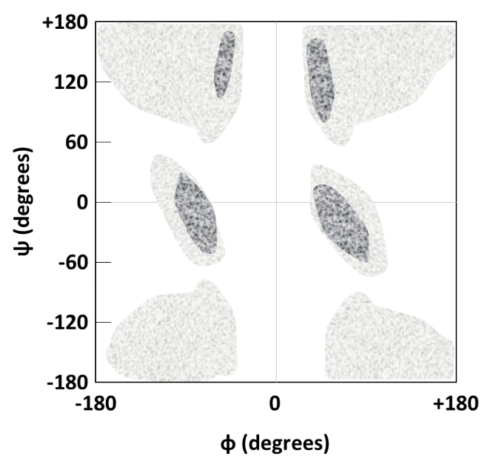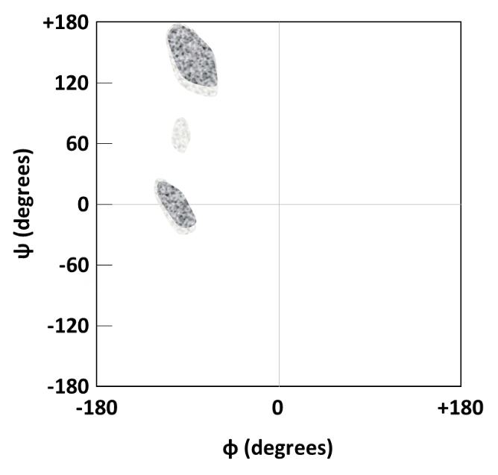
glycine or proline glycine or proline

Assessment:
(LG 1, 2)
- The dotted outlines in the following figures suggest the electron cloud of the amino acid displayed. The atoms are colored as follows: C, grey; O, red; N, blue; H, white.
First identify the kind of representation used to display the amino acid. Then identify the electron clouds as true (correct) or false (incorrect).
  - Asparagine’s representation: __Space fill__
  - T or F T or F T or F
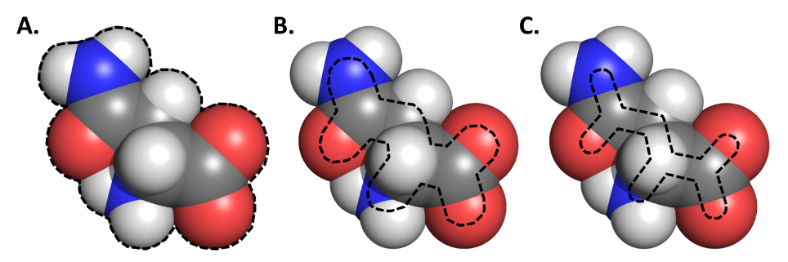

  - Histidine’s representation: __Stick__
  - T or F T or F T or F
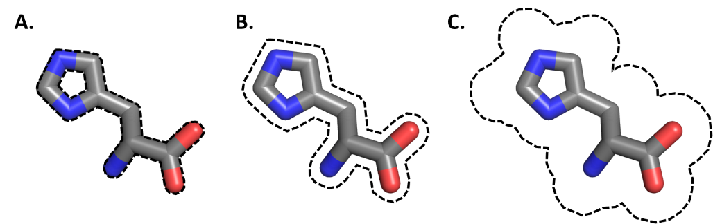

(LG 3)
- Use the following figure to identify the following components of peptide YAPKS. The atoms are colored as follows: C, grey; O, red; N, blue. For simplicity, Hs are not shown:
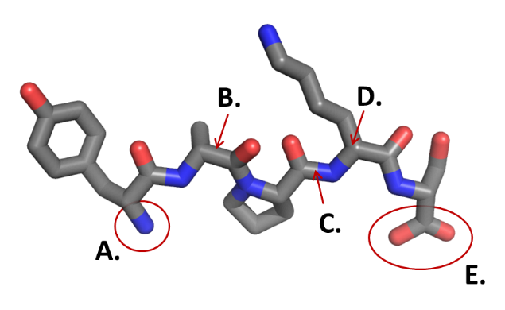
  - Alpha carbon
  - C-terminus
  - N-terminus
  - Peptide bond
  - Rotatable bond

(LG 3)
- Use the following chemical structure to identify the following components of peptide YAPKS. 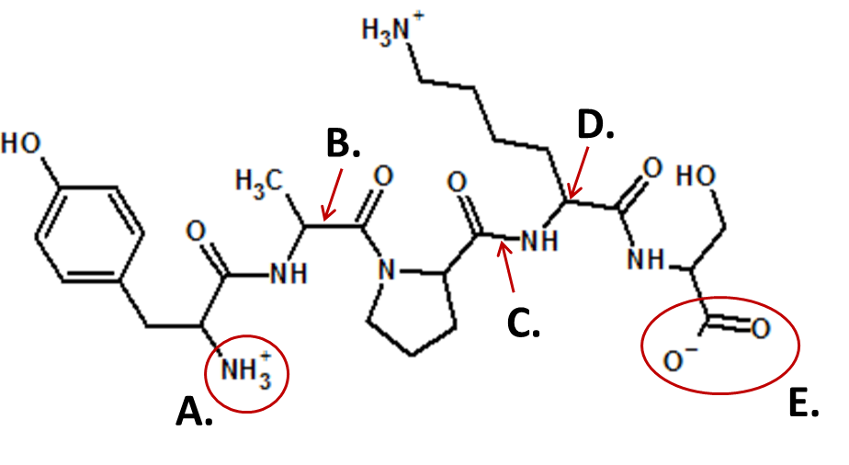
  - Alpha carbon
  - C-terminus
  - N-terminus
  - Peptide bond
  - Rotatable bond
(LG 4)
- Which of the following is/are true regarding amino acid orientations in a polypeptide?
T or F The peptide bond in proline is more rigid than in other amino acids.
T or F The peptide bond angles of proline are more constrained than those of other amino acids.
T or F Peptide bonds are free to rotate.
T or F Serine is able to rotate 360° around the phi and psi bonds (the bonds adjacent to the alpha carbon) in a polypeptide.
T or F The carboxyl oxygen of the peptide backbone has no effect on how freely an amino acid can rotate.
T or F The amine hydrogen of the peptide backbone affects how freely an amino acid can rotate.
T or F The bulkiness of amino acid side chains affects rotation around phi and psi bonds.

